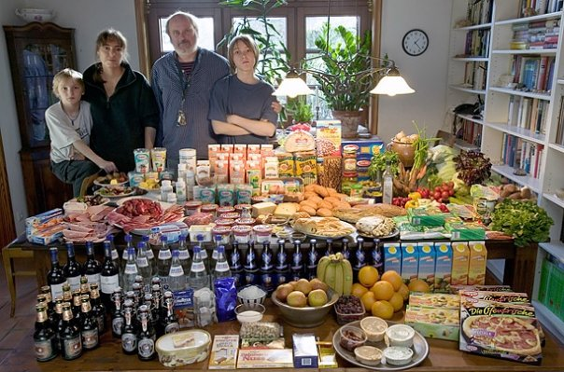
Germany: The Melander family of Bargteheide
Food expenditure for one week: 375.39 Euros or $500.07
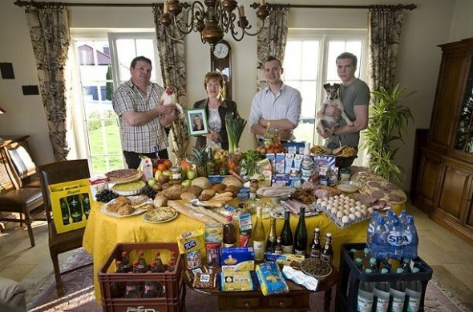
Luxembourg: The Kuttan-Kasses of Erpeldange
Food expenditure for one week: 347.64 Euros or $465.84
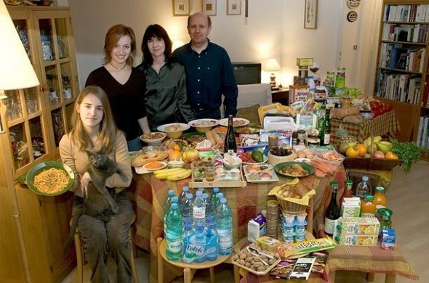
France: The Le Moines of Montreuil
Food expenditure for one week: 315.17 euros or $419.95
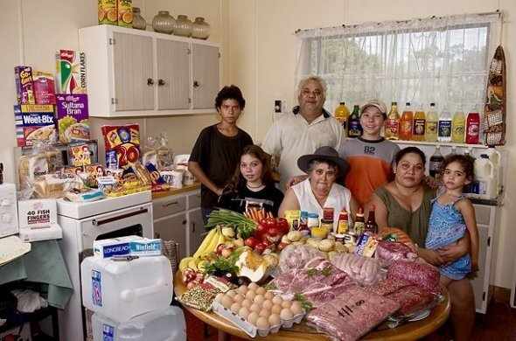
Australia: The Browns of River View
Food expenditure for one week: 481.14 Australian dollars or US$376.45

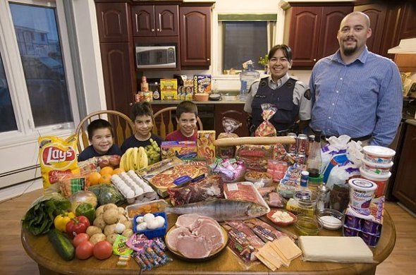
Canada: The Melansons of Iqaluit, Nunavut Territory
Food expenditure for one week: US$345
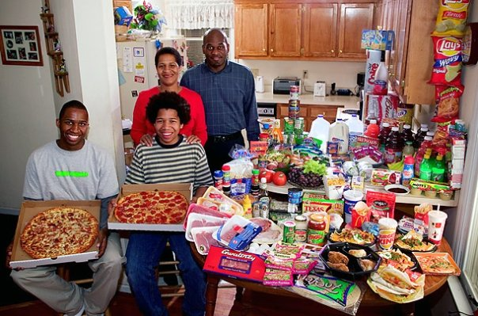
United States: The Revis family of North Carolina
Food expenditure for one week: $341.98

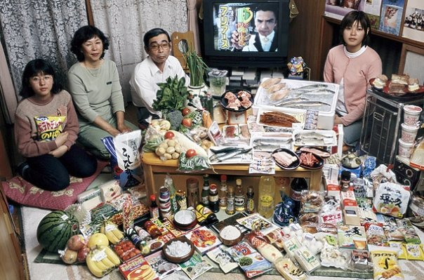
Japan: The Ukita family of Kodaira City
Food expenditure for one week: 37,699 Yen or $317.25
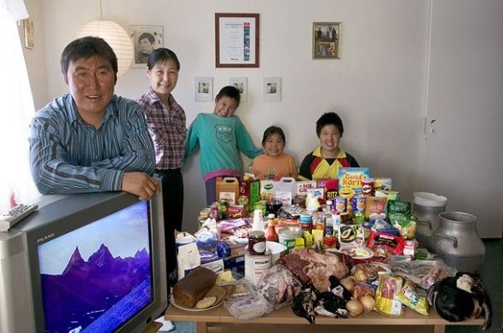
Greenland: The Madsens of Cap Hope
Food expenditure for one week: 1,928.80 Danish krone or $277.12

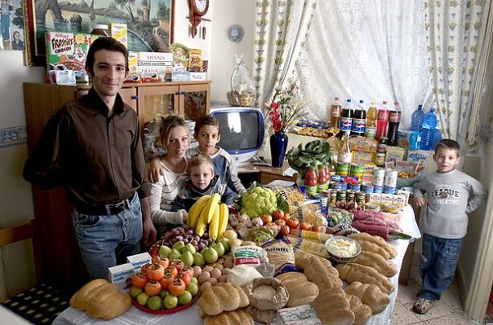
Italy: The Manzo family of Sicily
Food expenditure for one week: 214.36 Euros or $260.11
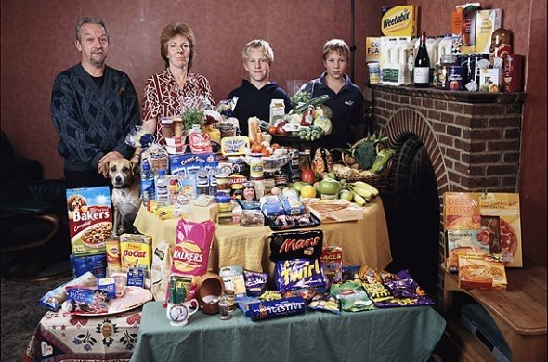
Great Britain: The Bainton family of Cllingbourne Ducis
Food expenditure for one week: 155.54 British Pounds or $253.15
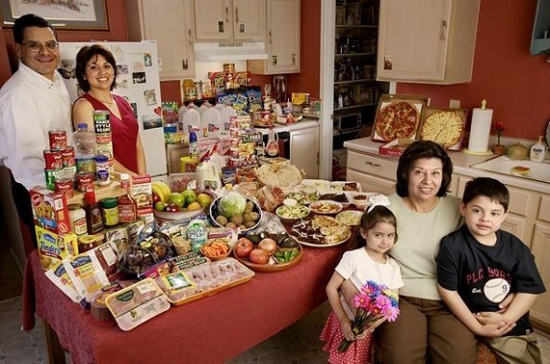
United States: The Fernandezes of Texas
Food expenditure for one week: $242.48
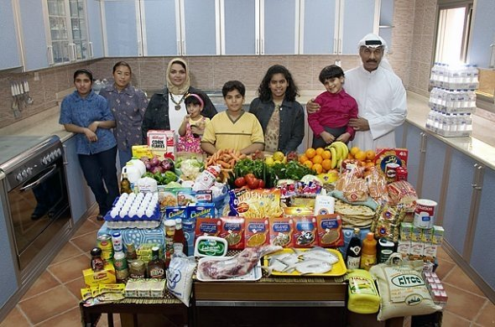
Kuwait: The Al Haggan family of Kuwait City
Food expenditure for one week: 63.63 dinar or $221.45
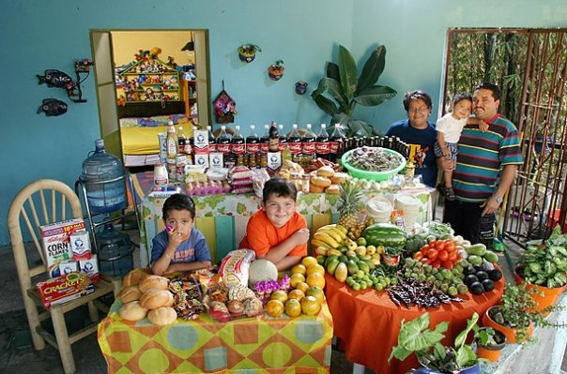
Mexico: The Casales family of Cuernavaca
Food expenditure for one week: 1,862.78 Mexican Pesos or $189.09
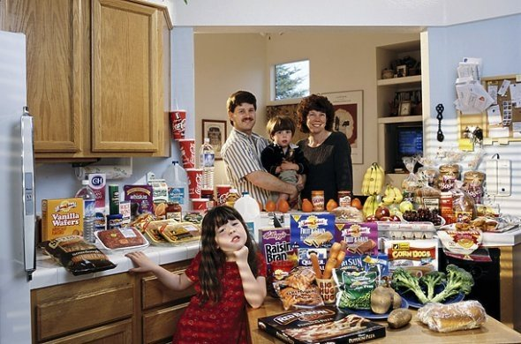
United States: The Caven family of California
Food expenditure for one week: $159.18

China: The Dong family of Beijing
Food expenditure for one week: 1,233.76 Yuan or $155.06
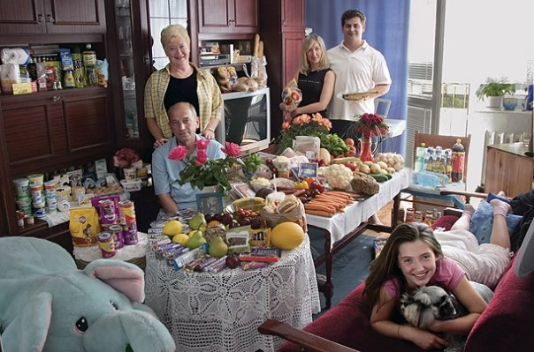
Poland: The Sobczynscy family of Konstancin-Jeziorna
Food expenditure for one week: 582.48 Zlotys or $151.27
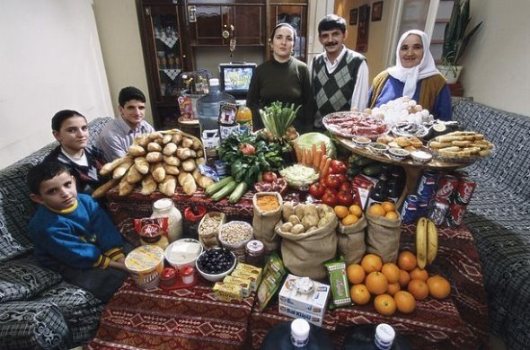
Turkey: The Celiks of Istanbul
Food expenditure for one week: 198.48 New Turkish liras or $145.88
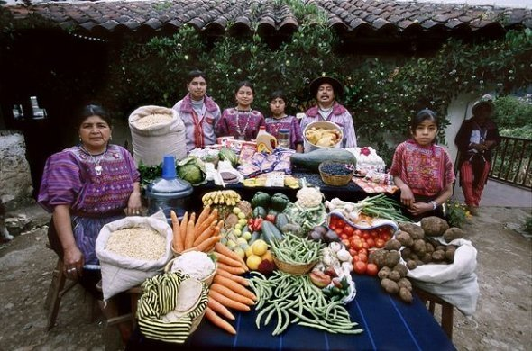
Guatemala: The Mendozas of Todos Santos
Food expenditure for one week: 573 Quetzales or $75.70
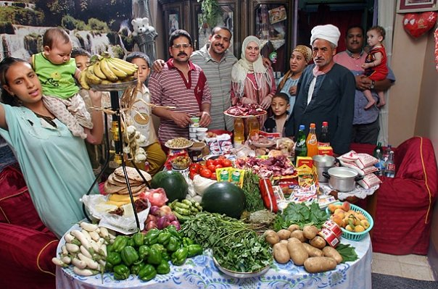
Egypt: The Ahmed family of Cairo
Food expenditure for one week: 387.85 Egyptian Pounds or $68.53

Mongolia: The Batsuuri family of Ulaanbaatar
Food expenditure for one week: 41,985.85 togrogs or $40.02

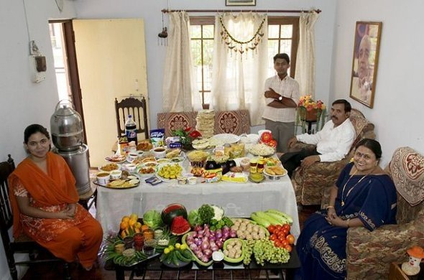
India: The Patkars of Ujjain
Food expenditure for one week: 1,636.25 rupees or $39.27
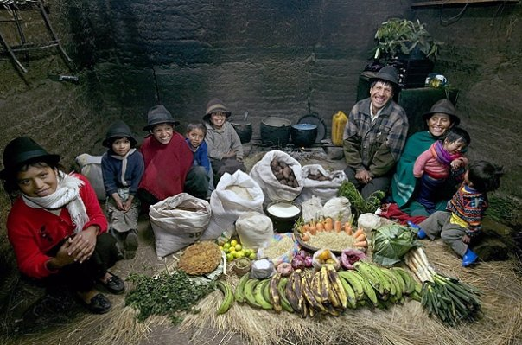
Ecuador: The Ayme family of Tingo
Food expenditure for one week: $31.55
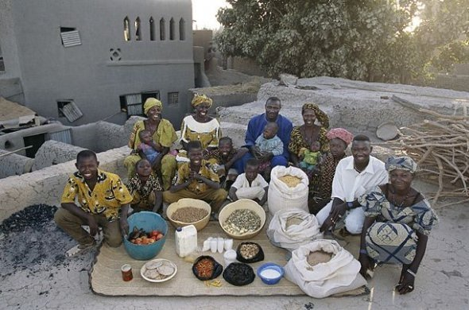
Mali: The Natomos of Kouakourou
Food expenditure for one week: 17,670 francs or $26.39
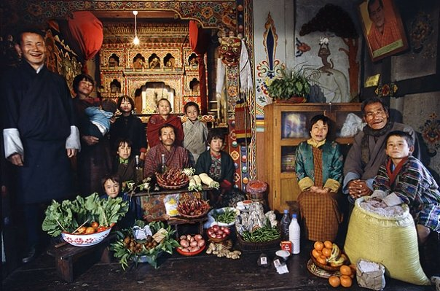
Bhutan: The Namgay family of Shingkhey Village
Food expenditure for one week: 224.93 ngultrum or $5.03
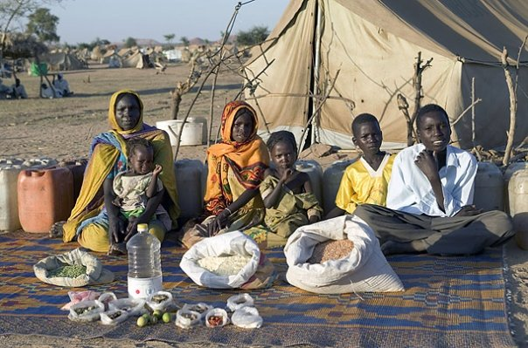
Chad: The Aboubakar family of Breidjing Camp
Food expenditure for one week: 685 CFA Francs or $1.23

